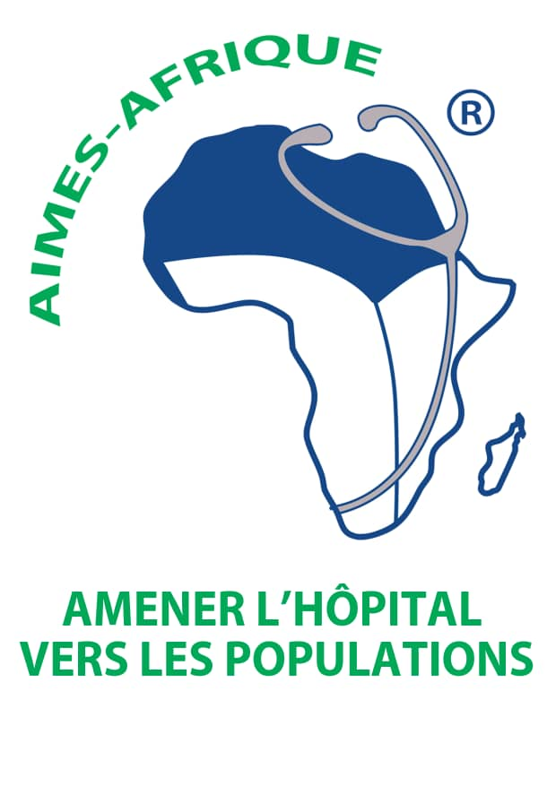
CONCEPTUAL NOTE

CONFERENCE ON THE CHALLENGES OF HEALTH CARE ACCESS IN RURAL ZONES IN AFRICA

Monday, December 16-20Th, 2019 - United Nations Palace - Geneva
Room XVIII

1.Introduction

AIMES - AFRICA, an international non-governmental organization, is "the International Association of Physicians for the Promotion of Education and Health in Africa."

To benefit from the ECOSOC Consultative Status since 2013, we have been active in the health field and act in programmes and operations for populations with little or no access to a quality health offer, particularly in Rural. Present on the ground for more than 14 years, our network of 500 African doctors, volunteers in our international solidarity projects allows us to act on behalf of target populations in rural areas. Our goal is to contribute to improving living conditions for sustainable access to quality care, regardless of race, religion. We are also a member of the General Assembly of the African Union Economic, Social and Cultural Council (ECOSOCC-AU) since 2014.

2.Context
In Africa, the provision of health care is still far from covering the entire population.
Access to health care remains a critical issue, while the right to health is a fundamental strategic element in achieving the Unit's Agenda 2030 Sustainable Development Goals (SDGs). | Goal 1| Goal 3 |Goal 10

The Declaration of the Rights of Farmers and Others Working in Rural Areas was adopted on 17 December 2018 by the United Nations.

AIMES-AFRIQUE, which has been leading this fight internationally for more than 14 years, wants to bring together actors and delegates in Geneva for a multi-stakeholder conference on access to rural health care.

Small-scale farmers, fishers, herders and others working in rural areas make up almost half of humanity, yet their rights are being denied in many countries.

Poverty, displacement, lack of financial resources, lack of water and above all, unequal and even lack of access to quality health care are just some of the problems they face regularly.

This declaration recognises, among other things, the right to land and natural resources, the right to a decent income and means of production, the right to social security, food sovereignty, and a quality standard of living in rural areas.

Poverty is a predominantly rural phenomenon, with more than 73.4% of the population living below the poverty line. This characteristic of poverty reflects the little progress in inclusion and regional disparities in Africa in particular.

The social-economic activities of AIMES-AFRIQUE to achieve self-sufficient food in the regions concerned.

Good health is essential to win the fight against poverty and social exclusion and contributes to the development and respect for human rights.

Therefore, it was necessary to continue raising awareness and to take advocacy on the issue of quality health care in rural areas; by involving civil society actors, to continue to improve the rights and living conditions of peasants and others working in the fields.

3.Goals
Specifically, the event will be an opportunity to:
- Spread and advocate for the implementation of the recommendations and messages of this declaration through information days (or other information) to actors working in the field;
- Establish a matrix of the potential of risks and barriers to implementing the strengthening of rural health systems;
- Strengthen partnerships with participating delegates' countries;
- Encourage the sharing of experiences and best practices as well as the promotion of engagement with all stakeholders;

4. Expected results
Participants mastered the UN declaration on peasant rights and pledged to share it and implement good health practices;
Participants will have an in-depth view of the challenges and difficulties of functioning health systems (safety/health) and become active players in development;
Participants in their respective countries share the achievements of the conference through programmes and seminars;
Civil society, through the Economic, Social Council (ECOSOC-UN) and Cultural Council (ECOSOCC-UA) is committed to intensifying their actions in rural areas.

5. Expected achievements
- A report compiling key messages and advocacy recommendations will be sent to key health actors, the UN, the African Union and African countries;
- The establishment of a mechanism to monitor the results of sharing and knowledge of the Declaration of the Rights of farmers and others working in rural areas;
- The African Union Economic And Cultural Council (ECOSOCC UA) is committed to supporting AIMES-AFRICA in mobilizing civil society actors to address health challenges in rural Africa;
- A documentary for broadcast for the teams and actors on the field.

6. Organization
The conference will take place from 16 to 20 December, from 10 a.m. to 12 p.m. and from 3 p.m. to 6 p.m. at the Palais des Nations in Geneva. The first day will be the opening session and speeches.

7. Participants: More than 40 countries expected
- Health decision-makers and leaders
- Civil Society organizations working in rural areas
- Participants and delegates of the ECOSOCC African Union
- Representatives of diplomatic delegations to the United Nations of the countries represented,
- Partners
- Representatives of the private sector, and civil society in Switzerland, involved in defence of peasant law
- Consultants and supporters of the conference theme
8. Format
Short speeches by keynote speakers
A panel discussion that provides the experts' views on the topic of this conference
We give the floor to participants for comment or questions and answers.

Senior Coordinator: Dr. Serge Michel KODOM, Tel: 0022890028595,
Email: dr.kodom@aimes-afrique.org
And associate coordinating Diana Comnos in Geneva

Program and sub-themes

December 16 - Opening of the Conference-Speech
United Nations declaration on the rights of peasants and others working in rural areas, as part of access to health care.

December 17
What are the sustainable solutions for a high-performance and beneficial health system for all?

December 18
Bringing Civil Society Organizations to Strengthen Health Systems: Challenges and Issues

December 19

Social responsibility and volunteerism within the medical profession
Closing of the Conference

December 20 - Half-day - UN Guided Tour

Program - Senior Panelist - Dr. Serge Michel KODOM

December 16 – First Day of the Conference United Nations Statement on the Rights of Farmers and Others Working in Rural Areas, as part of Access to Health Care.
MORNING
8.30 Am - 11 Am Registration of participants, handing over documents and information, a quick visit to the Palace.
11 Am -noon NGO presentation, purpose, missions, values

12.30pm – 2.50pm lunch break

AFTERNOON
3.pm – 4 pm Opening Ceremony
4.pm – 5 pm Advance/ Status quo (Presentation of the situation in African countries - Activism to promote Social and Cultural Economic Rights
5 pm – 6 pm Communication civil society on access to health care: Debates and discussions

December 17: What are the sustainable solutions for a high-performance and beneficial health system for all?
MORNING
10 Am - 11 Am Presentation and debate on the UN Declaration on the Rights of Farmers and Others Working in Rural Areas
11 Am - 11.30 Am Health and Safety
11.30 Am – noon Discussions and debates Questions/ Answers

12.30pm – 2.50pm Lunch

AFTERNOON
3 pm - 3.30 pm International Cooperation Agenda 21 – DGVS (City of Geneva: Waiting for answer)
3.30 pm - 4 pm What are the sustainable solutions for a high-performance and beneficial health system for all?
4 pm - 4.30 pm Presentation of the seven (7) pillars of the African Union Agenda 2063

December 18: Contribution of Civil Society Organizations in Strengthening Health Systems

MORNING
10.Am – 11. Am. Civil Society's Role in The Pursuit of universal Health for All Goals, as recommended by WHO - Issues and Challenges
11.30 Am - noon Farmers' Rights and the SDGs (Agenda 2030 Vs Agenda 2063 of the African Union)

12:30 - 14:50: Lunch break

MIDI AFTER

3 pm - 4 pm SDG 3 - Rural Health Rights: Sharing Experience in 10 Countries
4 pm - 5 pm Place of traditional medicine in rural Africa
5 pm - 6 pm Rural Care and Ethics: Generic Drug Place

December 19: Social Responsibility and Volunteering in the Medical Corps

morning
10 Am - 11 Am Voluntarist within the medical profession and Humanitarian Actions
11 Am - noon Health Actors Accountability in Health Promotion

12.30 pm - 2.50 pm Lunch Break

MIDI AFTER
3 pm - 3.30 pm Communication on Mental Health/ Non-Transmissible Diseases
3.30 pm - 4 pm Communication on Neglected Tropical Diseases (Noma)
4 pm – 4.30 pm Communication on One Heath-Health One (Men-Animals-Environment)
4.45 pm 5.30 pm Reports and Recommendations

5.30 pm - 6 pm Conference Closing Ceremony

December 20
08 Am – 12 Pm UN Guided Tour - Depart

To be confirmed
Republic and Canton of Geneva – Presentation of SSI

