INDICO

1.0 – P
Create and Activate an
Indico Account

KEY POINTS TO REMEMBER

WHY CREATE AN INDICO ACCOUNT?
An Indico account is required in order to register for events managed in Indico.
BROWSER COMPATIBILITY
Indico performs better with the following browsers:
Edge – Firefox – Chrome - Safari - Opera
PASSPORT / ID CARD
Have passport/ID card to hand while completing an Indico profile. Personal data must correspond with details contained in passports/on ID cards.
PICTURE
When submitting a registration form, upload a recent picture to it from your hard drive or take one with a webcam if your PC has a lens (registration forms contain an active camera function). A guide on picture standards is available.
EMAIL ADDRESS
The email address used when creating an Indico account must not already be in use by another Indico user. Email addresses are used as a unique identifier of users.

NO ACCOUNT ACTIVATION EMAIL
Before seeking assistance, check your SPAM folder or click on the resend account activation email option on the Indico log in page.
CHILDREN
Children under 14 are not required to register in Indico for an event if they accompany an adult who is registered and approved for the event.

STEP 1 – The “Log in to Indico” screen

- Navigate to https://reg.unog.ch/user/login and select the option create a new account.

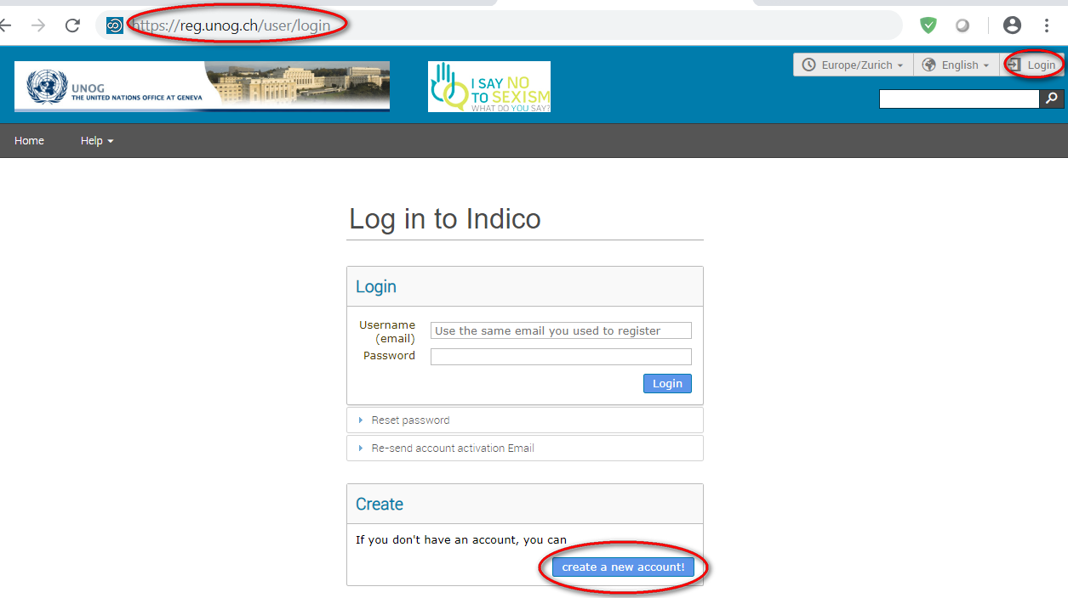

STEP 2 – The “Creating a new Indico user” screen

- Complete all information fields marked with “*” as these are mandatory.

- The email address entered will serve as the user ID for the newly created account.

- Ensure that all 6 criteria for establishing a password are met. (If the criteria for setting the password is not visible, it is probably due to an incompatible browser being used - switch to Chrome, Firefox, Safari, Edge or Opera).

- Solve the math sum under ARE YOU HUMAN? and click confirm.

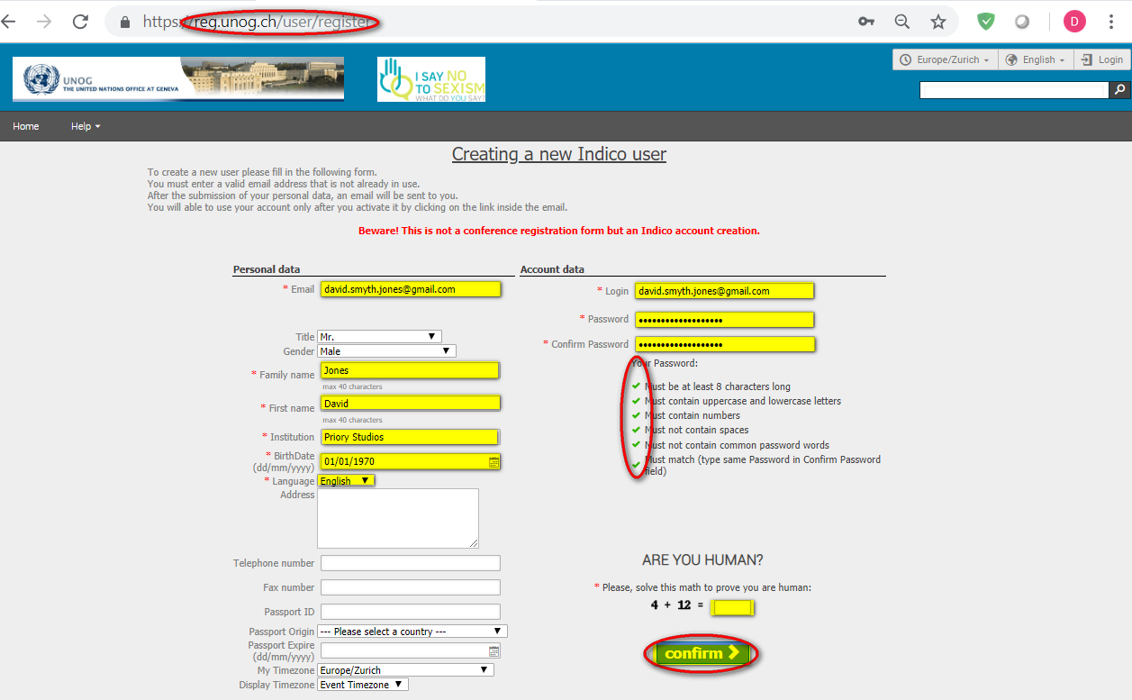

- A message appears on-screen confirming the successful creation of the account and advising you to check your email to activate the account.

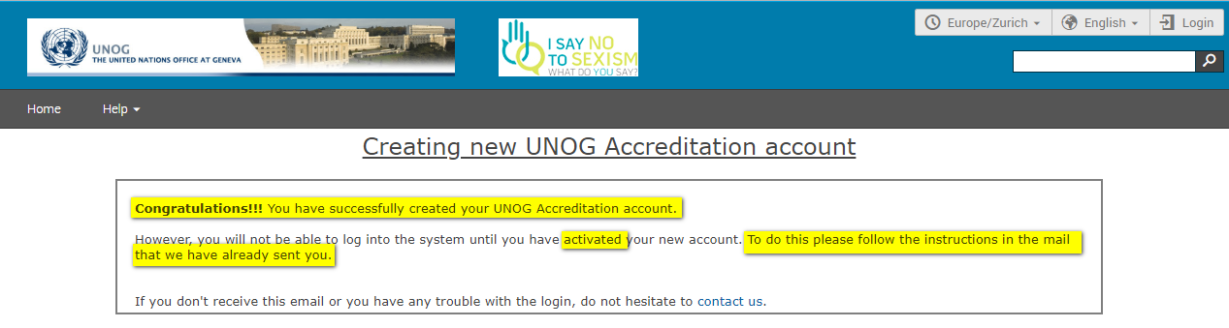

STEP 3 – The Indico account activation email

- In your email locate the Indico account activation email with the subject “Accreditation account confirmation”.

- If you fail to find the email, check your Spam or Junk folder. Alternatively, click the Re-send account activation Email link on the Indico log in page, enter the email address under which you created your Indico account and click Send account Activation Email. Check your email account again.

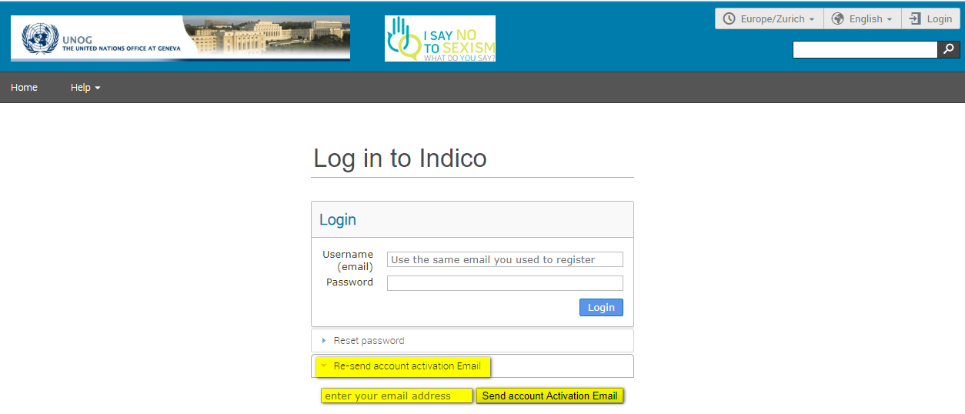

- After locating the Indico account activation email, open it and click on the activation link contained therein.

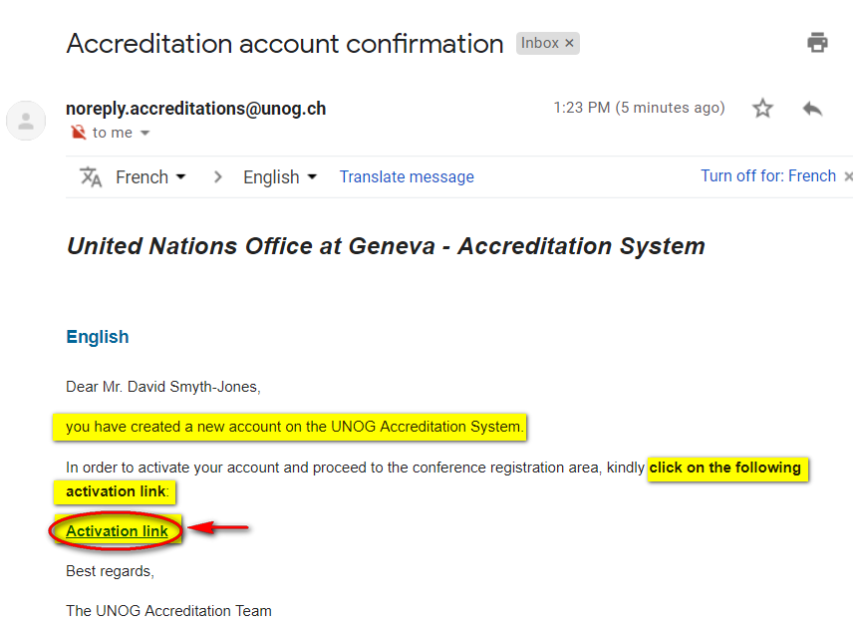

- A message appears on-screen confirming the account is activated.

- You may then log in to Indico by clicking on Login (top-right corner of the screen) or on Click HERE on the page.

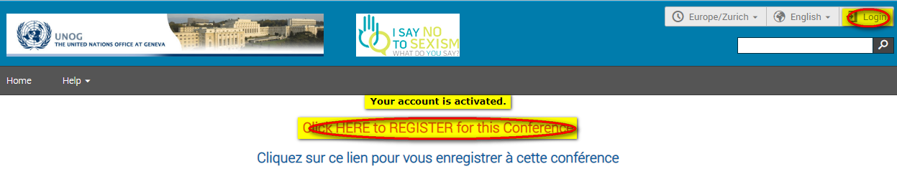

--- END ---

