Why is this important?

- Non-communicable diseases (NCDs) include cardiovascular disease, cancer, diabetes, chronic respiratory diseases and others.^{1,2,3}
- A lack of appropriate care for even a short period of time puts the health and well-being of people with NCDs at risk.⁴
- People whose health is compromised by NCDs are more vulnerable to the stresses and disruptions of disaster.^{5,6}
- Risk reduction of NCDs requires multi-sectoral action to promote healthy behaviours.¹
- NCDs are managed by a range of health services that address prevention, treatment, rehabilitation and palliative care.²
- Disaster resilient health infrastructure is required to ensure continuity of care in emergencies. Specific measures may include the protection of medical supplies.⁷
- A significant number of deaths after a disaster are as a result of inadequate health care services to cater for pre-existing conditions and illnesses.^{2,3}
The majority of ill health, disability and premature death around the globe is due to non- communicable diseases (NCDs).^{8,9} 70% of all global deaths are as a result of NCDs, 78% of which occur in low to middle income countries. Ten NCDs are a major cause of poverty, a barrier to economic development, and a neglected global emergency.¹⁰
A combination of population aging, increasing obesity, decreasing physical activity, environmental change and a reduction in communicable diseases has contributed to this epidemiological transition that has increased action on NCDs, including for emergency and disaster risk management.⁴ Many NCDs can result from behavioural risk factors like smoking, alcohol, lack of exercise and poor diet and are therefore, preventable.⁷

Key Points
NCDs require ongoing management for optimal out-comes, which is challenging in emergency settings because disasters increase the risk of acute exacerbations.¹¹ In disasters, access to chronic care treatment and medication is jeopardized, medical records may be lost, essential medications may be destroyed, and evacuees may forget to take them.³
Key Points
This challenge is recognized in the Sendai Framework for Disaster Risk Reduction: 2015-2030 (30k): “People with life-threatening and chronic disease, due to their particular needs, should be included in the design of policies and plans to manage their risks before, during and after disasters, including having access to life-saving services.”¹²
What are the health risks?
The risks associated with disasters for people with NCDs may be grouped into the following:^{1,2}
- Exacerbation of NCDs due to stress caused by a disaster. Consider the person with heart disease who must rapidly evacuate from a flash flood.
- Loss of life-sustaining medications or infrastructure such as loss of safe water and power, that can have life threatening consequences for those requiring to refrigerate medicines (insulin for diabetes) or attend for dialysis (renal failure).⁴
- Loss of access to health systems for patients with chronic and acute health needs, such as those undergoing chemotherapy or dialysis.
Hazardous events including disasters can also exacerbate the risk factors for the onset of NCDs; therefore, action is needed to prevent, screen and provide care for new and existing cases of NCDs after the acute emergency period has passed, in recovery and beyond.
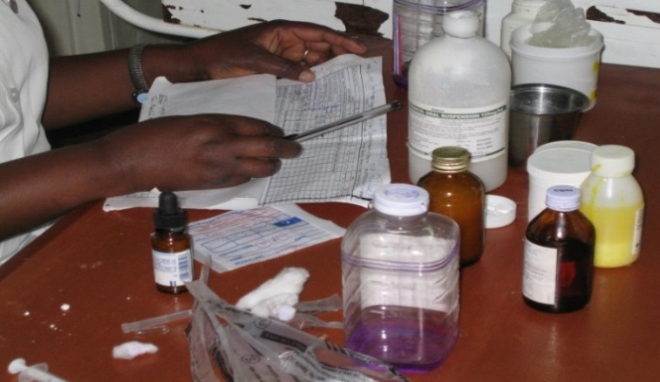Nurses checking prescription medication, Malawi.(Marko Kerac)

Risk management considerations
Governments and communities can ensure that the risk of NCDs in disasters is appropriately managed by:
- Undertaking risk assessments based on knowledge of pre-emergency patterns and prevalence of NCDs.⁸
- Organise NCD service delivery with a focus on primary health care.¹¹
- Utilizing technologies such as telehealth to provide treatment advice and geographical information systems for recording where those with NCD live and identifying them quickly in the response phase.^{6,7}
- Developing and implementing national legislation, policies and strategies to strengthen action on prevention and control of NCDs, which also take account management of NCDs in emergency situations.^{13,14}
- Development and adoption of NCD prevention and control strategies that aim to reduce the risk factors for NCDs,¹⁵ such as health promotion, regular physical activity, healthy diet, regular health visits, and reducing consumption of alcohol and tobacco.
- Protection of health facilities and equipment, which provide care for people with NCDs.
- Coordination with relevant NCD stakeholders, networks and partnerships for disaster risk assessment, preparedness and response and recovery planning.¹
- Recognising and addressing the special needs of those with NCDs in health sector plans in order to facilitate the transition of pre-emergency to emergency and post-emergency care.²
- Inclusion of essential drugs and supplies for people with chronic diseases in emergency health kits.
- Providing advice to individuals and carers on the development of personal management strategies and supporting patient-tailored disaster preparedness plans including evacuation strategies and back-up supply of medications.¹³
- Utilising surveillance tools before, during and after events to:
  - establish NCD baselines
  - facilitate needs assessments before, during and after emergencies
  - monitor and asses the effects of an emergency on NCDs
  - monitor and audit the short and long-term effects of emergency response on NCDs.
Hurricane Iniki (1992) One year post hurricane, 19% increase in cancer-related deaths.¹⁵
USA (2005): Jhung et al found that 68% of all medications dispensed to San Antonio evacuees following the 2005 New Orleans hurricane were for NCD treatment.³
Burkina Faso (2009): In Ouagadougou, Burkina Faso, the Ministry of Health reported that 50 renal dialysis patients had to stop treatments when dialysis machines were damaged or destroyed by flooding of the Yalgado University Hospital Centre. Some patients were in a critical state until three generators were found to continue their care.
Earthquake and tsunami, Japan (2011) Rate of cerebral infarction more than doubled in men over 75 years.¹⁶
Hurricane Sandy (2012): Cardiac incidents increased by 22%, mortality by 31% in the 30 days post event.¹⁷

References
- WHO (2011) Brazzaville Declaration on Noncommunicable Diseases Available at: www.afro.who.int/en/media-centre/pressreleases/2839-african-health-ministers-adopt-brazzaville-declaration-on-noncommunicable-diseases.htm
- Sondorp E, Chan E (2008) Including chronic disease care in emergency responses Humanitarian Exchange Magazine. Issue 41
- Jhung M, Shehab N, Rohr-Allegrini C, Pollock D, Sanchez R, Guerra F, Jernigan D (2007) Chronic disease and disasters: medication demands of hurricane Katrina evacuees Am J Prev Med 33(3)
- Ryan et al (2015). Identifying and Describing the Impact of Cyclone, Storm and Flood Related Disasters on Treatment Management, Care and Exacerbations of Non-communicable Diseases and the Implications for Public Health. PLOS Currents: Disasters 2015(1).
- Mensah et al (2005) When Chronic Conditions Become Acute: Prevention and Control of Chronic Diseases and Adverse Health Outcomes During Natural Disasters. Preventing chronic disease. Public health research, practice and policy vol (2) pp1-4
- Mokdad AH, Mensah GA, Posner SF, Reed E, Simoes EJ, Engelgau M. When chronic conditions become acute: prevention and control of chronic diseases and adverse health outcomes during natural disasters. Prev Chronic Dis 2005;2(Suppl 1):A04.
- Ryan et al (2016). Reducing Disaster Exacerbated Non-communicable Diseases Through Public Health Infrastructure Resilience: Perspectives of Australian Disaster Service Providers. PLOS Currents Disasters.
- Rath et al (2007). Adverse health outcomes after Hurricane Katrina among children and adolescents with chronic conditions. Journal of Health Care for the Poor & Underserved; 18(2):405-417.
- Chan E, Kim J (2011). Chronic health needs immediately after natural disasters in middle-income countries: the case of the 2008 Sichuan, China earthquake. European Journal of Emergency Medicine; 18(2):111-114.
- WHO (2017). The top 10 causes of death. Available at: http://www.who.int/mediacentre/factsheets/fs310/en/
- Slama S et al. Care of non-communicable diseases in emergencies. Lancet; 389(10066):326-330.
- UNISDR (United Nations International Strategy for Disaster Reduction). Sendai framework for disaster risk reduction 2015–2030. UNISDR, 2015.
- Ryan B, Franklin R (2017). Disaster Trends and Impact. In: Publications. R, editor. Disaster Health Management: Primer for Students and Practitioners. Routledge Publications.
- Aldrich N, Benson W (2008) Disaster Preparedness and the chronic disease needs of vulnerable older adults Preventing chronic disease: public health research, practice and policy vol (5) pp1-7. Available at: http://www.cdc.gov/pcd//issues/2008/jan/07_0135.htm
- The NCD Alliance (2016) No Progress Without Action. https://ncdalliance.org/sites/default/files/resource_files/WHA70_infographic_EN_final.pdf.
- Hendrickson L (1996). Mortality of Kauai residents in the 12-month period following Hurricane Iniki. American journal of epidemiology; 144(2):188-191.
- Omama S et al (2013). ‘Influence of the Great East Japan earthquake and tsunami 2011 on occurrence of cerebrovascular diseases in Iwate, Japan.’ Stroke, 2013; 44(6): 1518–1524.
- Swerdel JN et al (2014). ‘The effect of Hurricane Sandy on cardiovascular events in New Jersey’. Journal of the American Heart Association; 3(6)
Presentations to Medical Centres in Mass Gatherings
Common Complaints | Uncommon Complaints
Injuries  Heat-Related Illness  Intoxication Gastrointestinal Illness Respiratory disorders | Hypothermia  Head Injury  Loss of consciousness  Asthma  Cardiac Chest Pain

