Example: South Asia
Earthquake and Tsunami (2004)

The Sumatra-Andaman earthquake and tsunami of
26th December 2004 led to an estimated 226,408 deaths across South Asia.²
Post-event analysis in three of the countries affected, Sri Lanka, Indonesia, and Thailand, showed that a lack of co-ordination between different organizations, communities and family members resulted initially in a lack of clear process for body recovery.²
Bodies were taken to multiple locations and surviving relatives suffered greatly in not knowing where family members had been taken.²
Key Points
Why is this important?
Key Points
Most disasters that result in large numbers of fatalities occur in countries where population vulnerability is increased by poverty, often compounded by limited infrastructure, inadequate health systems and poor disaster preparedness, response and recovery programs.
Larger-scale natural disasters may result in many tens of thousands of fatalities⁴, while smaller-scale disasters involving multiple deaths often exceed the local capacities for mass fatality management.
In 2010, the earthquake in Haiti is estimated to have caused over 200,000 deaths, a heat-wave in Russia over 55,000 and floods in Pakistan almost 2,000.⁵ Other types of disaster, including epidemics, bombings and chemical hazards (e.g. Bhopal, India), may also result in large numbers of dead bodies.
Since 2011, it is estimated that the internal conflict in Syria has led to over 60,000 deaths, the earthquake in Japan over 15,000 and the typhoon in the Philippines almost 1000.
While local facilities may be able to manage small numbers of the dead, they are rarely able to cope with the hundreds or thousands of fatalities which may occur in an emergency. When the number of bodies exceeds the capacity of normal local mortuary arrangements, mass fatality management plans may be activated to provide the additional capacity.⁶
Mass fatality incidents: number of deaths by event type (2012)
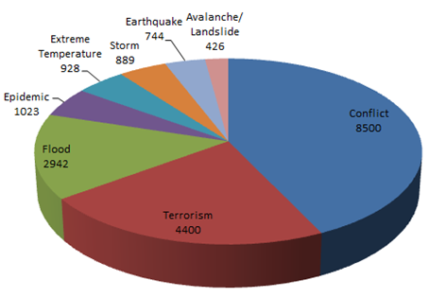
Data Source: EM-DAT (2012)

- The health risk to the general public from large numbers of dead bodies following emergencies arising from natural hazards is negligible.1,2
- Capacity is needed to recover, identify, store and dispose of the large number of dead bodies that may arise in an emergency1,2.
- It is important for the psychosocial wellbeing of the living: survivors, relatives and the wider com- munity that the dead are managed with dignity and respect. 1,2
- Good communication on the management arrangements for dealing with the dead and the missing is critical for relatives.1
- Awareness of ethical, religious and cultural sensitivity are important for those managing fatalities.¹
- Exposure of civilian populations to chemical, bio- logical and radiological agents is an increasing hazard, and fatalities as a result of such hazards may pose an ongoing threat.3
- Please also see factsheets on chemical safety, radiation, communicable diseases, and mental health and psychosocial support.

What are the health risks?
General risks¹
The major risk is inadequate capacity to deal with dead bodies, which may result in:
- Distress to families and the community.
- Diversion of vital community, health and disaster responders away from priority life-saving measures for survivors to the management of dead bodies.
- Inappropriate practices may also cause community distress.
The health risk to the general public from large numbers of dead bodies arising from natural hazards is negligible.¹ However, there is a risk of infection arising from consumption of water that is contaminated with faeces from a dead person.
There may also be health risks through secondary contamination from fatalities as a result of exposure to chemical or radiological agents.³
Psychological distress amongst the bereaved is aggravated if they are unable to perform funereal rites in accordance with their local custom.^{1,2}
Occupational health related risks¹
There are no reports of infection arising from contact with a dead body following environmental disasters, though long-term follow-up of personnel is yet to be undertaken. There are, however, risks associated with the handling of those who have died of certain diseases, most notably viral haemorrhagic diseases such as Ebola.⁷ Risk assessments need to be made where fatalities arise following epidemics of infectious disease or exposure to chemical or radiological agents to prevent infection and/or secondary contamination.^{1,4}
(NB. The majority of health effects following a natural disaster include injury/strain from lifting bodies, and injury from debris during body recovery).⁸
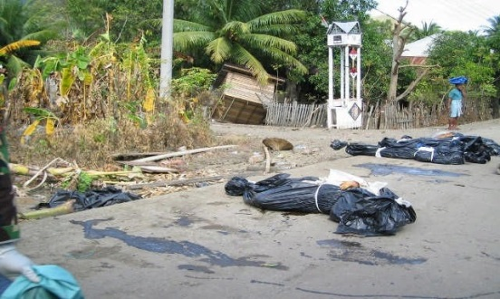
It is vital in all cases that universal precautions are adhered to when handling dead bodies, including wearing gloves and washing hands. Additional personal protective equipment may be needed when handling fatalities occurring as a result of chemical, biological and radiological incidents, and specialist advice should be sought.

Risk management considerations
Governments and communities can ensure that mass fatalities are appropriately managed by:
- Taking coordinated multi-agency planning and preparedness measures for the management and recording of fatalities specifically addressing each of the following four stages involved in management of dead bodies:¹
  - Body recovery
  - Storage of bodies: as local custom permits, in refrigeration, cold storage or by other means until identification and handing over to family members.
  - Victim identification: using fingerprints, dental records, DNA records, photo identification depending on local resources and baseline identification records.
  - Disposal, which should reflect ethnic and religious sensitivities where possible and appropriate.
- Additionally, following chemical, biological and radiological events, taking steps to identify and contain the causative agent.
- Effectively communicating risk to survivors and responders including health workers, emergency responders and those living in risk prone areas about the adverse health effects from a dead person.¹
- Provide access to support mechanisms for survivors, relatives and those dealing with fatalities.
References
- Management of Dead Bodies after Disasters: A Field Manual for First Responders. Second (revised) Edition. Washington, D.C. : PAHO, 2016.
- Morgan OW, Sribanditmongkol P, Perera C, Sulasmi Y, Van Alphen D, Sondorp E. Mass Fatality Management following the South Asian Tsunami Disaster: Case Studies in Thailand, Indonesia and Sri Lanka. PLoS Med 2006;3(6): e195. doi:10.1371/journal.pmed.0030195
- Eberwine D. Disaster Myths That Just Won’t Die. Perspectives in Health 2005;10(1):2-7.
- Baker DJ, Jones KA, Mobbs SF, Sepai O, Morgan D, Murray VSG. Safe Management of Mass Fatalities following Chemical, Biological and Radiological Incidents. Prehosp Dis Med 2009;24(3):180-188.

- CRED (Center for Research in Epidemiology of Disasters) (2011). 2010 disasters in numbers. Available at: http://cred.be/sites/default/files/PressConference2010.pdf
- EM-DAT http://www.emdat.be/, Refugees International. Available at: http://refugeesinternational.org/
- Richards P, Amara J, Ferme MC, et al. Social pathways for Ebola virus disease in rural Sierra Leone, and some implications for containment. PLoS Negl Trop Dis 2014; October 31
- European Agency for Safety and Health at Work. Emergency services: a literature review on occupational health and safety risks. Available at: https://osha.europa.eu/en/tools-and-publications/publications/literature_reviews/emergency_services_occupational_safety_and_health_risks
Presentations to Medical Centres in Mass Gatherings
Common Complaints | Uncommon Complaints
Injuries  Heat-Related Illness  Intoxication Gastrointestinal Illness Respiratory disorders | Hypothermia  Head Injury  Loss of consciousness  Asthma  Cardiac Chest Pain

- Tsunami fatalities (2004), Indonesia (WHO)

