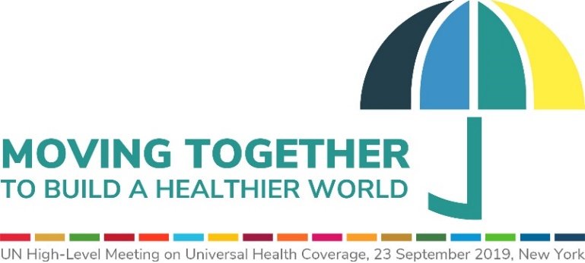

INTERACTIVE MULTI-STAKEHOLDER HEARING
UN General Assembly Hall, New York, 29 April
DRAFT CONCEPT NOTE AND PROGRAMME

I. Background
In accordance with UN General Assembly resolution 72/139 and 73/131, a high-level meeting (UN HLM) on universal health coverage (UHC) will be convened on 23 September 2019 with the overall theme: Universal Health Coverage: Moving Together to Build a Healthier World.
As part of the preparations leading to UH HLM, the President of the General Assembly (PGA) was requested to convene, with support from the World Health Organization (WHO) and the International Health Partnership for UHC 2030 (UHC2030), an interactive multi-stakeholder hearing (Hearing) to ensure the inclusive, active and substantive engagement of multi-stakeholders in the process (A/RES 73/131).

II. Introduction
UHC means that all people and communities receive the quality health services they need, without financial hardship. Key barriers to UHC achievement include poor infrastructures and availability of basic amenities, out of pocket payments and catastrophic expenditures, shortages and maldistribution of qualified health workers, prohibitively expensive good quality medicines and medical products, low access to digital health and innovative technologies, among others.
Each of these barriers has solutions that not only lead to UHC but also boost the economy and have an important impact on other SDGs. For example, Goal 1 (end poverty), Goal 4 (quality education), Goal 5 (gender equality), Goal 8 (decent work and economic growth), Goal 9 (infrastructure), Goal 10 (reduce inequality), Goal 16 (justice and peace), and Goal 17 (partnerships). UHC is a catalyst for socio-economic development and a key contributor to equity, social justice and inclusive economic growth. UHC delivers on the human right to health as well as the broader human rights agenda.
Primary health care (PHC) is the foundation for UHC. PHC oriented health systems provide quality services that are comprehensive, continuous, coordinated and people-centered. With these characteristics along with its emphasis on prevention and promotion, PHC reduces inequities in health, and is highly effective and efficient, particularly for the management of chronic conditions such as non-communicable diseases, including mental health.

III. Objective
The purpose of the Hearing is to benefit from the perspectives of all stakeholders, on urgent actions and investments for UHC, and to provide a key opportunity to identify how the UHC political declaration (i.e. outcome document of UN HLM) can add value to the current UHC movement and set a concrete milestone to accelerate progress towards achievement of UHC by 2030.

III. Audience
The Hearing will bring together representatives of the Member States, observers of the General Assembly, parliamentarians, representative of local government, relevant UN entities, civil society organizations, non-governmental organizations, academia, professional associations and the private sector and broader communities. This includes ensuring the participation and voices of women, children, youth and indigenous leadership.

IV. Format
The one-day interactive Hearing will be divided into:
- An opening segment

- Three interactive panel discussions. Each panel will feature up to four speakers, including representatives of multi-stakeholder constituencies with diverse backgrounds. Sessions will include statements from panelists, stories from the field related to the theme of the session, audience polling on specific questions and facilitated discussions with the panelists to answer questions raised from the floor. At the end of the session, moderators will wrap up and summarize key points. Priority of interventions from the floor (approximately 15-20 interventions per session) will be given to joint statements of global, regional or country constituencies of non-governmental organizations, civil society organizations, academic institutions, philanthropic foundations, health professional associations and the private sector. Other written interventions will be posted on WHO and/or UHC2030 webpage as needed.

- A closing segment.

V. Themes
The thematic areas and sub-topics are:
- UHC as a driver for inclusive development and prosperity
- Contextualizing the achievement of UHC within the broader development agenda.
- Emphasizing the importance of UHC as an umbrella for health, and a contributor to social justice and inclusive economic growth.
- Recognizing that advancing UHC delivers on the human right to health as well as the broader human rights agenda.

- Leave No One Behind – UHC as a commitment to equity
- Social accountability for UHC and aligning investments to needs.
- Addressing the determinants of health and reaching every person and community with quality integrated and person-centered PHC.
- Improving monitoring and feedback mechanisms to hold leaders accountable to promises of health for all and progress toward stronger, more equitable health systems.

- Multi-sectoral and multi-stakeholder actions and investments for UHC
- Uniting all health actors and initiatives firmly behind our commitment to UHC.
- Ensuring that all people, regardless of race, gender, age, citizenship or ability, are represented in the movement for UHC.
- Building cross-sectoral mechanisms for coordinated actions and investments for UHC.
- Strengthening capacity of local authorities to engage communities and implement actions for UHC.
- Mobilizing more domestic resources, harmonizing investment in health, using resources equitably and efficiently, and optimizing resources from different sectors and actors for UHC.

VI. Outcome
The outcome will be a summary prepared by the President of the General Assembly. It will be circulated to all Member States and other stakeholders.

PROVISIONAL PROGRAMME

10:00-10:30 | Opening Segment
10:30-13:00 | Session 1: UHC as a driver for inclusive development and prosperity  - Contextualising the achievement of UHC within the broader development agenda.  - Emphasizing the importance of UHC as an umbrella for health, and a contributor to social justice and inclusive economic growth.  - Recognizing that advancing UHC delivers on the human right to health as well as the broader human rights agenda.
13:00-15:00 | Lunch Time
15:00-16:15 | Session 2. Leave No One Behind – UHC as a commitment to equity  - Social accountability for UHC and aligning investments to needs.  - Addressing the determinants of health and reaching every person and community with quality integrated and person-centered primary health care.  - Improving monitoring and feedback mechanisms to hold leaders accountable to promises of Health for All and progress toward stronger, more equitable health systems.
16:15 - 17:30 | Session 3. Multi-sectoral and Multi-stakeholder Action and investments for UHC  - Uniting all health actors and initiatives firmly behind our commitment to UHC.  - Ensuring that all people, regardless of race, gender, age, citizenship or ability, are represented in the movement for UHC.  - Building cross-sectoral mechanisms for coordinated actions and investments for UHC.  - Strengthening capacity of local authorities to engage communities and implement actions for UHC.  - Mobilizing more domestic resources, harmonizing investment in health, using resources equitably and efficiently, and optimizing resources from different sectors and actors for UHC.
17:30 - 18:00 | Closing Segment

